Mercer County Community College Prof. Porter MAT151 Practice Exam 1

NAME:____________________

- What is Calculus?

What is varying in calculus?

What is the derivative?

- Use the δ-ε definition of limits to show that 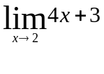 is 11.

Answer:____________________

- Evaluate the limit: 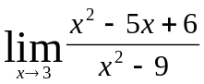

Answer:____________________

Explain on when the function is continuous .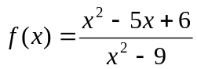

Answer:____________________

When is the function removable discontinuous?

Answer:____________________

- Given the function, find A so that the function is continuous: 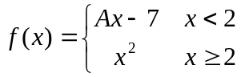

Answer:____________________

Give a qualitative graph of the continuous function.

- Evaluate the limit 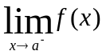

A | 0 | 1 | 2 | 3 | 4 | ∞
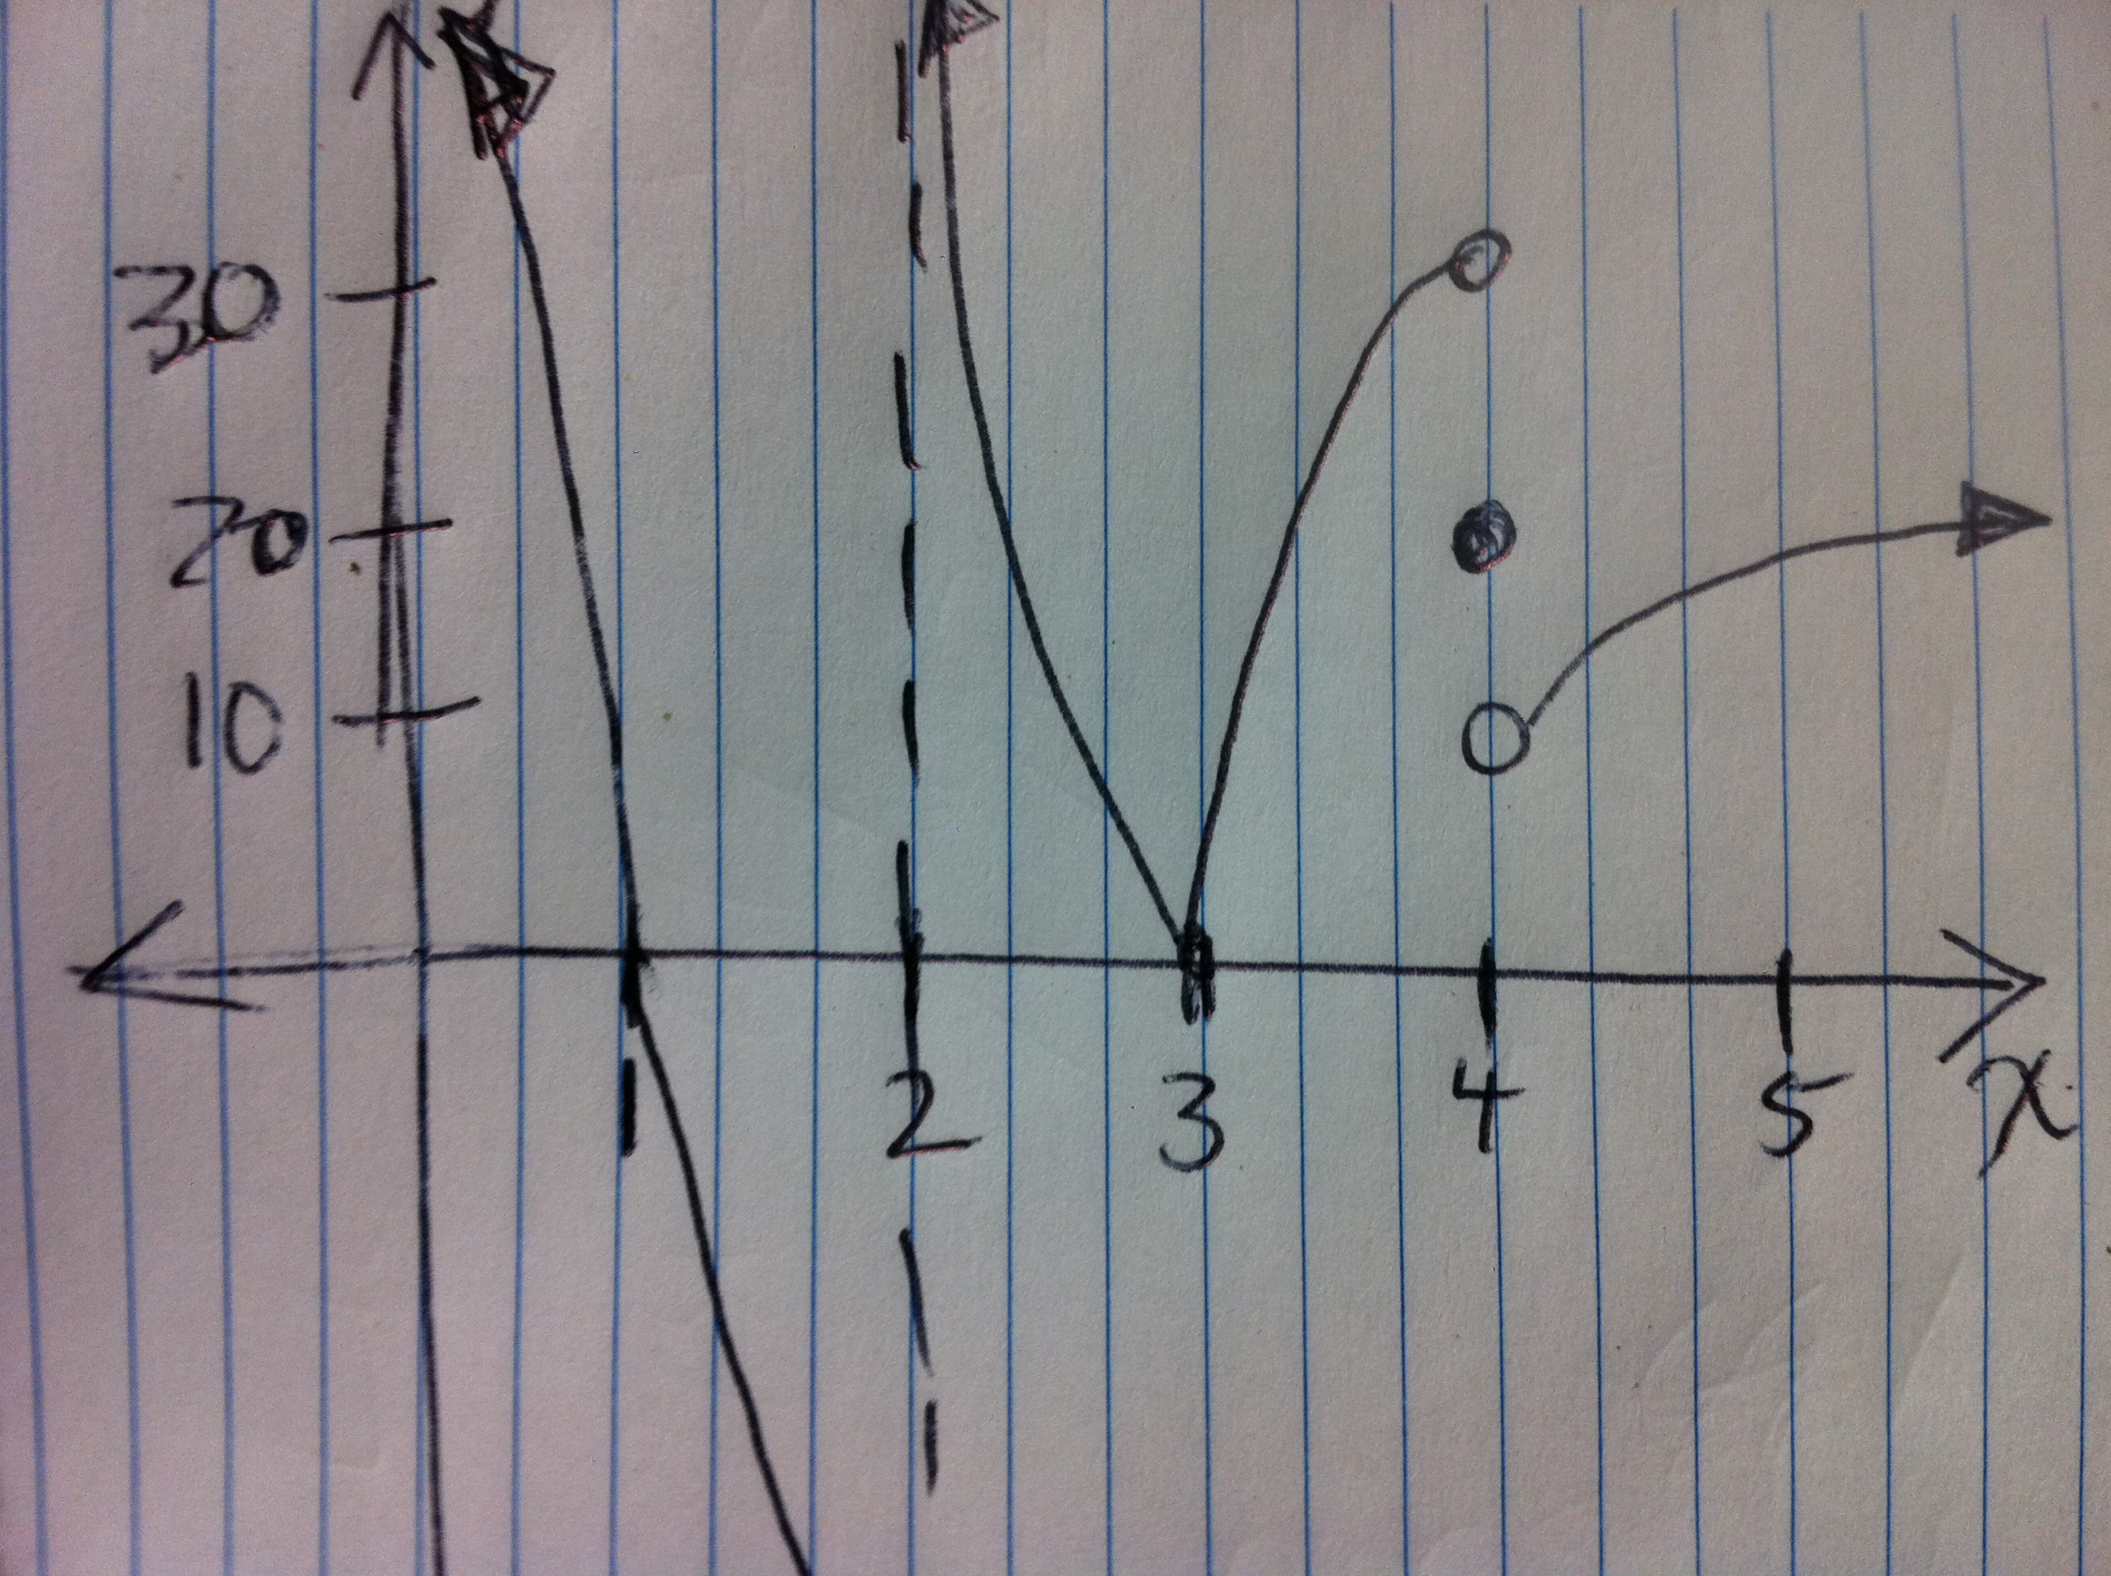

- Given the same graph above, determine f’(x) approximately at 1, 2, 3, 0
X= | 1 | 2 | 3 | 4 | ∞
f’(x)

- h(t) = t (2 – t) + 3 represents the height of a ball at time t.
Evaluate the function at 0 and 2 and use that information to find the average speed of the ball between t = 0 and t = 2.

Answer:_________________
Find the instantaneous speed at t = 1 for this problem.

Answer:_________________

- Use the definition of derivative to find f’(x) if f(x) = x( x + 1)

Be sure to give f(x+h) clearly.

Answer:____________________________
(No credit for just answer- must use definition!)
- Find f’ of the following:
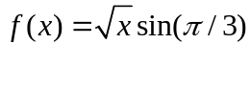

Answer:____________________________
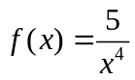

Answer:___________________________

- Evaluate the limit

- 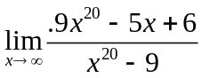

Answer:____________________

- 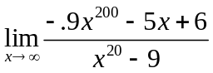

Answer:____________________
- 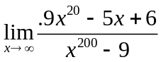

Answer:____________________
- 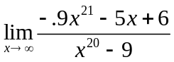

Answer:____________________

- Given the data, perform a quartic regression and determine the max/ mins.

Year: | 8 | 10 | 12 | 13 | 15
Salary: | 35 | 45 | 46 | 48 | 54

- Use the same data to determine the left end limit at infinity

