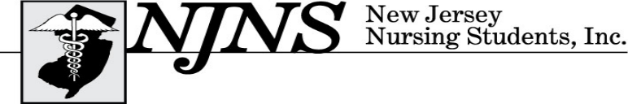
Nursing: Honoring the Past and Shaping the Future
64th Annual Convention – Thursday and Friday, March 3-4, 2016
Bally’s Atlantic City ∙ 1900 Pacific Ave ∙ Atlantic City ∙ NJ ∙ 08401

DELEGATE APPLICATION
DUE BY February 15, 2016

Delegates MUST be current NSNA members and maintain a GPA of 2.5. Delegates may NOT serve as monitors.

ALL delegates will receive FREE registration. Delegates must attend ALL delegate meetings and participate in voting. Delegates are also required to remain at the convention from 4:00 pm Wednesday through 2:00 pm Friday.
Hotel room reservations are the sole responsibility of the attendee. The NJNS, Inc. room rate is $59 or $69 plus tax. To reserve a room, call Bally’s directly at (609) 340-2000 and identify yourself with New Jersey Nursing Students, Inc. convention to receive the discounted rate. Use discount code SB03NS6. Room rate is guaranteed through February 15 2016. The hotel will request a deposit equivalent to the first night’s rate plus taxes per room. Check in time is 4pm. Early check in fees will be the responsibility of room occupants. Check with your dean/director regarding financial assistance.

Delegate Duties:
- Represent your school of nursing
- Attend ALL House of Delegates meetings and vote on business issues, bylaws, and the resolution if applicable

Delegate representation for your school is based on NSNA membership as of February 3,2016.
If you have a question regarding your school membership, please contact us for clarification.

# NSNA Members | # Delegates |  | # NSNA Members | # Delegates |  | # NSNA Members | # Delegates
1-25 | 1 |  | 101-125 | 5 |  | 201-225 | 9
26-50 | 2 |  | 126-150 | 6 |  | 226-250 | 10
51-75 | 3 |  | 151-175 | 7 |  | 251-275 | 11
76-100 | 4 |  | 176-200 | 8 |  | 276-300 | 12

THE APPLICATION MUST BE FILLED OUT COMPLETELY OR IT WILL NOT BE PROCESSED.

Please Print
First Name: Last Name: NSNA # (REQUIRED):

Address:

Phone Number: Email:

School of Nursing: Is GPA 2.5 or above:

Dean/Director Signature:
Are you planning to attend the NCLEX Test Taking Strategies on Friday for $10? Yes No
or
Are you planning to attend The Silver Lining to Nursing School on Friday for $10? Yes No

Are you planning to attend the First Night Party on Thursday night (includes dinner, music, photo booth) for $15 ? Yes No
Total Enclosed: $__________

If you have any other questions, please contact Regina Adams, BSN, RN via email at staff@njnsinc.org
Please mail applications to
New Jersey Nursing Students, Inc. Attn: Regina Adams, BSN, RN, 1479 Pennington Road, Trenton, NJ 08618-2694
UNDER AGE POLICY
Persons under the age of 21 will be prohibited from the casino floor at Bally’s while attending the convention.

Photography Release Waiver: By registering and attending the NJNS, Inc. convention I hereby give my permission for my name, photograph, or likeness to be used by NJNS and/or NSNA within any media in which it appears without NJNS and/or NSNA incurring any debts or liabilities of any kind.

