

NURSING PROGRAM
HANDBOOK

INFORMATION PACKET
SPRING 2006

Greetings!

To all of our new and returning students to the Spring 2006 semester. The Nursing Program Handbook will outline vital information regarding your upcoming semester in the nursing program. It also includes procedures for students to follow.

All students are responsible for the information contained in the handbook, so take some time to become familiar with its contents. The final page of the handbook is an acknowledgement that you have read, understand, and agree with the information presented. This form is to be filled out, signed and returned to your instructor or the nursing education office by the end of the first class week.

I look forward to working with you toward your goal of becoming a registered professional nurse.

Sincerely,

Linda Martin

Linda A. Martin, RN, MSN, APRN, BC, CNE
Director, Nursing Education
Equal Employment Policy

Mercer County Community College is committed to a policy of equal opportunity and non-discrimination against individuals on the basis of personal beliefs or characteristics such as political views, religion, national or ethnic origin, race, color, gender, sexual orientation, age, marital status, veteran status or disability unrelated to job or program requirements.

Questions regarding the equal opportunity policy and compliance statement may be directed to the Equal Opportunity Officer or ADA Compliance Officer, West Windsor Campus, (609) 586-4800, ext 3601 or 3615.

Nursing Program Accreditation

The college’s nursing program is accredited by the New Jersey Board of Nursing, 124 Halsey Street, 6th Floor, Newark, NJ 07102, (973) 504-6430 and the National League for Nursing Accreditation Commission, 61 Broadway, New York City, New York, 10006, (212) 363-5555.
TABLE OF CONTENTS

MERCER COUNTY COMMUNITY COLLEGE 4
DIVISION OF SCIENCE & ALLIED HEALTH 4
PHILOSOPHY AND PURPOSE OF THE ASSOCIATE DEGREE PROGRAM IN NURSING 4
Program Objectives 5
Program Outcomes 6
Definitions 7
MISSION STATEMENT 8
VISION STATEMENT 8
LEGAL REQUIREMENTS FOR LICENSURE 9
ACADEMIC REQUIREMENTS/INFORMATION 10
Courses Required In The Program 10
Courses Completed at Other Colleges 11
Description of Nursing Courses for Associate Degree 11
LPN-RN Advance Placement Program 12
Method of Instruction 12
SPECIAL REQUIREMENTS 14
Health Records 14
Accident and Health Insurance 15
Liability Insurance 16
Cardio-Pulmonary Resuscitation (CPR) 16
Cellphones and Pages 16
NURSING PROGRAM POLICIES 17
Academic Integrity 17
Attendance 18
Grading 18
Grade Appeal (See Student Calendar / Handbook) 19
Policy Regarding Readmission/Repeating Nursing Courses 21
Guidelines for Graded Papers, Reports, Etc. 22
Guidelines For Use Of The College Laboratory 22
General Policies Regarding Clinical Laboratory 23
Uniforms/Dress Code 25
LOCATION OF CLINICAL AGENCIES AND PARKING 27

MERCER COUNTY COMMUNITY COLLEGE

DIVISION OF SCIENCE & ALLIED HEALTH
Nursing Program

PHILOSOPHY AND PURPOSE OF THE ASSOCIATE DEGREE PROGRAM IN NURSING

The Nursing Department, as part of the Division of Science and Allied Health, is an integral part of Mercer County Community College and reflects the philosophy and objectives of the college. The nursing faculty accepts the responsibility of helping to meet the nursing needs of the community by providing a program in nursing for selected individuals within the administrative framework and educational climate of the college. The Nursing Department accepts students for enrollment regardless of race, color, religion, creed, marital status, national origin or ancestry, age or gender. Upon successful completion of the program, the individual will receive the Associate in Science degree and be eligible to take the examination for licensure as a registered nurse.

The nursing faculty believes that general education ensures that students develop a broad base of knowledge and become proficient in the use of skills indispensable to a positive and productive life: reading analytically, communicating ideas clearly, and competently solving essential scientific and mathematical problems. This enables the student to attain effective relationships with people and to make unique contributions to a multicultural society as a productive citizen and person.

The nursing faculty believes that nursing education is a planned program of experiences designed to promote the development of cognitive, affective and psychomotor learning for the basis of application of critical thinking in nursing practice. Current nursing knowledge, including concepts, principles and skills focused upon the nursing process, provide a foundation to develop professionalism, effective interpersonal and communication skills and proficiency in nursing practice. Nursing education is a life-long learning process.

The nursing faculty believes that man has physical, social, cultural, spiritual and psychological needs and that these needs are met through constant interaction with the environment, by adapting and readapting to internal and external forces throughout the life cycle. This environment can be modified and can be therapeutic. Nursing represents a dynamic system, which continually evolves, influences and changes as it reflects society's health needs. It encompasses prevention, therapeutic nursing interventions and rehabilitation, as well as promotion and maintenance of optimal health.

The Nursing Curriculum is planned with a balance of general education and nursing courses. The student learns by active participation in planned educational experiences as well as extra-curricular activities, with resultant changes in behavior. This process can best take place in an atmosphere conducive to learning which is provided through appropriate facilities and resources, carefully selected client assignments, qualified faculty, challenging learning situations and interaction between students and faculty. Graduates of the program will be eligible to take the National Council Licensure Examination in Nursing; with satisfactory achievement will be licensed as a Registered Nurse. The curriculum facilitates the students' transfer into a baccalaureate-nursing program.

The nursing faculty believes that the role of the associate degree nurse is to assist individual clients of all ages and backgrounds to maintain optimum health, to prevent illness and to deliver nursing care by assessing, planning, implementing, evaluating and thereby making nursing judgments based on scientific knowledge that is factual and specific. These graduates will be able to manage human responses to common health problems through the use of the nursing process in collaboration with health care providers in various care settings. We also believe that the Associate Degree Nurse will accept the responsibility for increasing competence by utilizing resources for continuing education.

Program Objectives

Guided by these principles and beliefs, Mercer County Community College provides a program, which will prepare a nurse who, will function with technical competence within the various care settings. This graduate will:

- Function within the provisions of the Nurse Practice Act.
- Maintain the Code of Ethics of the nursing profession.
- Accept responsibility for self-growth and learning within the profession of nursing.
- Utilize standards of practice while implementing and evaluating client care.
- Incorporate within nursing practice advocacy for client rights.
- Actively participate in professional organizations.
- Understand forces that impact upon the delivery of health care including socio-economics, community needs and political parameters.
- Utilize the principles of effective therapeutic communication within the healthcare setting.
- Assess the client’s health status in a comprehensive and holistic manner within various settings including available community resources.
- Assess the client’s response to care as the clients’ needs change.
- Identify the client's needs for information, instruction and skills related to health and take appropriate action.
- Analyze, synthesize and evaluate client-related data to establish a plan of care to meet client’s outcomes.
- Provide individual client care that demonstrates the application of principles derived from nursing, medical, natural and behavioral sciences.
- Implement caring behaviors that reflect the client’s/significant other’s values, religious customs, culture and/or habits.
- Provide a safe physical & psychological environment.
- Assist the client/significant other to cope with/adapt to stressful events/changes in health status as well as end-of-life decisions.
- Develop and implement individualized teaching plan based upon the client’s/significant others assessment needs, incorporating essential information for informed health care choices.
- Instruct and delegate assisting personnel to support the achievement of the client’s outcomes.
- Evaluate the achievement of client outcomes.
- Works cooperatively and collaboratively with the interdisciplinary health-care team across a variety of healthcare settings, to achieve/facilitate client and organizational outcomes in a cost-effective manner.

Program Outcomes

- Each class of graduates will pass the NCLEX-RN with a minimum pass rate of 80% on the first attempt.
2. Matriculated students will maintain a 70% graduation rate within six semesters.
3. 70% of graduates from the program will be employed in nursing within 6 months of passing NCLEX.

Reviewed: 7/03, 10/05
Revision: 7/04, 7/05

Definitions

Communication
Communication is a process of exchanging ideas and feelings. It occurs when meaning is conveyed from one person to another, verbally and nonverbally. Communication is the key to every other interpersonal skill (Peris Mary Hamilton).

Critical Thinking
Critical thinking is a dynamic developmental process reflecting knowledge, skill, logic and problem solving techniques relevant to nursing which is essential to patient outcomes affecting clinical judgments in health care.

A critical thinker is open minded, an active communicator, flexible and analytical. The skill of critical thinking incorporates ideas, is open to suggestions to be creatively effective and is considerate of the opinion of others.

Clinical thinking is reflective of critical reasoning. This involves the competencies of critical thinking, which are: interpretation, analysis, inferences, explanation and evaluation. Therefore, critical thinking is accomplished by self regulating, objective, decision making which benefits the members of society with goal directed approaches. Critical thinking empowers the nurse to contribute to improved health care practice. It is through consistent ongoing evaluation that human responses and human potential are maximized.

The nurse must be able to communicate through reading, writing, making oral reports, as well as by hearing, touching and seeing when rendering care. Language use must be appropriate for client, peer and other health care workers. The use of telephone and computer information systems enhances the nurse’s ability to provide input and service health care information.

Therapeutic Communication
Therapeutic Communication is a way of being helpful by facilitating interactions that are focused on the client and the client’s concerns. The purpose of therapeutic communication is to help the client express and work through feelings and problems related to his or her condition, treatment, and nursing care (Craven, Hirnle).

It also allows for the establishment and maintenance of the interpersonal relations between clients and families, significant others, and other health care professionals. It must include respect for individuals while acknowledging differences in culture, gender, and developmental stages. Therapeutic communication encompasses the attributes of empathy, caring, protectiveness, genuineness, objectivity, and openness.

Therapeutic Nursing Intervention
Therapeutic nursing interventions are behaviors implemented by the RN, which may be independently initiated or delegated by a healthcare provider. Interventions require nursing knowledge, assessment and skills as well as awareness of the client’s level of growth and development, culture, religion, education and economic status. As a health care team member, the nurse works collaboratively with the client, significant others, the extended family and/or community to accomplish goals. Desired patient outcomes and responses assist a client to maintain, improve or restore health or prevent illness in an individualized/holistic manner. The registered nurse functions within a societal and political structure, upholding standards and practices that affect the client in a beneficial way.

MISSION STATEMENT

The Nursing Program at Mercer County Community College welcomes students of all ages from a wide variety of ethnic backgrounds, abilities, interests, levels of education, and economic circumstances to a challenging and supportive educational environment. The program is thus designed to provide an educational framework whereby students develop a broad knowledge base enabling them to read analytically, communicate clearly and think critically in order to problem-solve. The faculty is committed to promoting student success from admission through graduation. Through the nursing process, students will utilize their learned skills of prevention, therapeutic interventions and rehabilitation as well as promotion and maintenance of optimal health in order to meet the health needs of the community we serve. Students will be prepared to make unique contributions to a multicultural society as professional, ethical health care providers.

VISION STATEMENT

The vision for the Mercer County Community College Nursing Program is to profoundly change the lives of the students we teach by providing the opportunity for them to become members of the nursing profession. We pledge to offer this opportunity to all students regardless of race, color, religion, creed, disability, marital status, national origin or ancestry, age, gender, economic circumstances or sexual orientation. We are committed to student success and believe a supportive learning environment is essential to that outcome. Achievement of our vision for the Nursing Program and its ongoing value to the Mercer County community shall be measured by the successful assimilation of our graduates into the nursing profession.

LEGAL REQUIREMENTS FOR LICENSURE

The Nurse Practice Act of the State of New Jersey Board of Nursing Statues (NJSA 45:11-26 et seq.) and Regulations (NJSA 13:37) govern the legal practice of nursing in the state. It is important that applicants who plan to study nursing know that licensure requirements include the following:

"An applicant for a license to practice professional nursing shall submit to the board evidence in such form as the board may prescribe that said applicant...is of good moral character, is not a habitual user of drugs, and has never been convicted or has not pleaded nolo contendere, non vult contendere or non vult to an indictment, information or complaint alleging a violation of any Federal or State law relating to narcotic drugs;"

In addition, the official application for professional nurse licensure by examination requires that applicants respond to the following questions:

A. Have you ever been an abuser or habitual user of chemical substance? If yes, provide the details of your drug use, including the period and nature of this use and any recovery. Attach a written report or detailed letter from a qualified counselor indicating his/her opinion about your current fitness to practice nursing.

B. Have you ever stolen or distributed (for profit or not) any chemical substance? If yes, provide the details of the episode(s).

C. Have you ever been treated for alcoholism or alcohol abuse? If yes, provide the details of your alcoholism recovery. Attach a report or detailed letter from a qualified counselor indicating his/her opinion about your current fitness to practice nursing.

D. Have you been indicted or convicted of any crime within the last ten (10) years? If yes, attach a copy of the indictment and judgment of conviction. If probation has been completed, attach a copy of the Termination from Probation order.

Thus, before beginning the nursing program, applicants must consider whether there is any legal reason why they might not be qualified for licensure. A criminal background check is now required for all new licenses. The New Jersey Board of Nursing has the authority to deny licensure if the applicant has a criminal record.

The Board of Nursing makes a determination on an individual case basis at the time of application for licensure. Applicants should consider their current lifestyle and personal history before embarking on a course of study in order to insure that, even though successful in completing the nursing program, they are not ineligible for licensure.

Questions and concerns regarding these laws may be discussed in confidence with the Director of Nursing Education. Applicants may, if they prefer, call anonymously to discuss their situation with the Director.

ACADEMIC REQUIREMENTS/INFORMATION

Courses Required In The Program
The Nursing curriculum will follow the program for the Associate in Science Degree (AS).

BIO 103: | Anatomy & Physiology I (3/3)
BIO 104: | Anatomy & Physiology II (3/3)
BIO 201: | Microbiology (3/3)
CHE 107: | General & Physiologic Chemistry (3/2)
ENG 101: | English Composition I (3/0)
ENG 102: | English Composition II (3/0)
MAT 102/ 135/ 141/200: | College Algebra (3/0); Intermediate Algebra with Applications (4/0); or College Algebra with Applications (4/0); or Statistics (3/0)
PSY 101: | Introductory Psychology (3/0)
 | *General Education Electives – 3 credits from Society and Human Behavior AND
 | *3 credits from any Historical Perspective, Diversity and Global Perspective, Aesthetic Perspective or Foreign Language
NUR 101: | Nursing I (3/4/6)
NUR 112: | Nursing II (3/2/12)
NUR 201: | Nursing III (3/2/12)
NUR 202: | Nursing IV (3/2/12)
NUR 203: | Nursing V (1/0)

* Check with Academic Advisor regarding electives.

HPE 110, Concepts of Health & Fitness, or HPE 111, Living with Health, required for students who do not demonstrate competency** by the time they enter Nursing III.

**Competency is demonstrated by successfully challenging the course. For further information, please contact Prof. Robert Pugh (MS147), ext. 3230 or 3743; email: pughb@mccc.edu.

HPE 304, CPR for Professionals, required for those who do not hold certification in CPR. All nursing students must hold current CPR certification while enrolled in the nursing courses.

Note: A grade of C or better is required in all science and nursing courses. A cumulative GPA of 2.0 is required for graduation.

It is the student's responsibility to check the College catalog regarding requirements for graduation to assure completion of appropriate courses. Should there be any question regarding acceptability of coursework, the student should meet with the Program Director. By the time of registration for NUR 202 and NUR 203, all required courses should be on the transcript or final semester schedule.

Shortly after the start of classes for NUR 202 & NUR 203, an application for graduation should be filed with the Student Records Office. A $35.00 fee is assessed. (fee subject to change) Deadlines for filing for graduation are October 1st for January and February 1st for May.

If you are unable to pass the final semester, you will need to re-apply for graduation and pay another $35.00 fee.

Courses Completed at Other Colleges

If you complete an applicable science, mathematics or other course at another college, it is your responsibility to insure that Mercer receives transcript evidence and that the corresponding MCCC course is entered on your transcript. To make this verification, consult with the Assistant Registrar, Student Records Office, approximately one month after the start of your first semester, or as appropriate.

Description of Nursing Courses for Associate Degree

NUR 101 Nursing I 7 credits
Introduction of concepts, knowledge from the social, psychological and physical sciences, and skills necessary to meet the basic needs of all clients. The nursing process is used as a framework for care delivery. Clinical experiences are planned in area health care agencies.

3 lecture/4 college laboratory/6 clinical laboratory hours

NUR 112 Nursing II 8 credits
Continuation of the concepts, knowledge and skills introduced in NUR 101 with an emphasis on meeting the nursing needs of clients with common health problems. Care of the client during the childbearing cycle is included. Selected clinical learning experiences in hospitals and health care agencies.
3 lecture/2 college laboratory/12 clinical laboratory hours

NUR 201 Nursing III 8 credits
Emphasis is placed on the further application of knowledge from the social, psychological and physical sciences to nursing care of clients of all ages with acute and complex nursing needs. The development of nursing skills is continued. Clinical experiences are planned in medical/surgical, pediatric and psychiatric facilities.
3 lecture/2 college laboratory/12 clinical laboratory hours

NUR 202 Nursing IV 8 credits
A continuation of NUR 201 with emphasis on the client who requires some permanent modification of life style in order to achieve or maintain optimal health. Development of management and delegatory skills are included. Clinical experiences are planned in medical-surgical, pediatric and psychiatric facilities.
3 lecture/2 college laboratory/12 clinical laboratory hours

NUR 203 Nursing V 1 credit
Designed to assist the student in assuming the role of the bedside nurse. Consideration of licensure, legal aspects of the nursing and professional organizations.
Corequisite: NUR 202 1 lecture hour

LPN-RN Advance Placement Program

The LPN-RN advanced placement option offers licensed practical nurses the opportunity to review content, demonstrate competency, and receive credit for Nursing I and Nursing II. Applicants must possess a high school diploma (or equivalent) and a valid LPN license. Upon successful completion of the advanced placement sequence described below, LPNs receive 15 credits and placement into Nursing III of the college's associate degree program.

Candidates admitted through the LPN option begin study with the general education and core science and mathematics courses required for the degree. Credit is given for Nursing I (NUR101) and the student is able to either enroll in Nursing II (NUR112) or test out of it via NUR176, LPN Advanced Placement II. Students who meet the requirements of this course receive 8 credits for Nursing II (NUR 112) and are eligible to proceed to Nursing III (NUR201). Students who complete the college's nursing program receive the Associate in Science (A.S.) degree and will be eligible to take the National Council Licensure Examination (NCLEX) for Registered Nurses (RNs).

Licensed Practical Nurses (LPNs) who wish to challenge Nursing II (NUR 112) must meet the following criteria in addition to the criteria outlined in the Nursing Admission Policy:

- Have graduated from an accredited LPN school.
- Have a valid current LPN license.
- Attend scheduled classes on identified content
- Have completed obstetrical theory and practice in the LPN curriculum.
- Pass the Excelsior’s Maternity and Child Nursing (associate degree) exam with a standard score of 50 or better.
- Have received credit for BIO 103/104, BIO 201 and CHE 107 with a grade of "C" or better.
- Pass a NUR 112 exam with a score of 75 or better.
- Validate NUR 112 skills in the College Laboratory.
- Write a nursing care plan that meets course objectives.
- Satisfactorily complete a 1-2 day clinical evaluation.

Upon successful completion of the challenge to NUR 112, the student will be placed in NUR 201. If the student is unable to successfully complete the NUR 112 challenge, then he/she will need to take the NUR 112 course.

Method of Instruction

- Lecture: Presentations may include new content, clarification or amplification of specified content.

- College Lab: All audio-visual and computer-assisted instructional materials are available in the lab. Demonstrations of required skills will be scheduled.

During the college lab session you are expected to utilize the required media programs, complete assigned activities and practice the skills which have been demonstrated.

Each student is required to demonstrate mastery of each selected skill for the Visual Evaluation. Skills should be practiced prior to the evaluation. Individuals will vary in how much practice is needed to achieve mastery of a particular skill. Standard precautions are to be utilized as appropriate in the performance of skills in the college lab setting.

3. Clinical Lab: Each session will include conference and patient care activities. In order to assure the needed clinical experiences for all students, it may be necessary to schedule certain experiences at times other than those listed on the class schedule. Students will be notified of such changes in sufficient time to make such personal arrangements as needed.

Clinical assignments will be placed in either a folder or envelope accessible to the student outside the coordinator’s office by 6:00 PM on the day prior to each clinical lab for those in the daytime sections or as arranged by the clinical instructor. For evening/weekend students, the assignments will be available the evening prior to the scheduled clinical or as arranged by the clinical instructor. Please discuss any issues or exceptions with your coordinator. Also, make sure your instructors and the nursing office have up to date e-mail, phone and address information.

Preparation for the clinical lab will be reviewed by the course coordinator and/or the clinical instructor at the orientation session. Students are expected to come to the lab with evidence of prior preparation. Faculty are authorized to deny a student the privilege of participation in clinical laboratory sessions when the student is unprepared, the student presents a health hazard to clients, when performance falls below a competent level with regard to patient safety or when the student does not meet agency health standards.

In such situations, participation in clinical laboratory experiences will be discontinued until there is evidence that the student's progress meets minimal criteria for safe clinical performance.

4. Testing: The Learning Center may be used for selected testing in Nursing I, II, III and IV. Students with certified special learning needs must make testing arrangements with the Learning Center and notify the Nursing office of those arrangements.

For nursing tests, no dictionaries or reference books are to be used. Only the scantron forms will be scored.

An overall grade average of 75% or better is required on the tests.

The Nursing Curriculum is structured so that you are actively involved in your learning. If you are having difficulty with the lecture materials, seek help from the classroom instructor; for clinical problems, seek a meeting with the clinical instructor. The student may choose to meet with the course coordinator or program director if further assistance is needed. If available, a tutor may be able to assist you in your studies. Please see the Director of Nursing Education for availability.

SPECIAL REQUIREMENTS

Health Records

1. All students entering the nursing program for the first time must submit a completed Physician's Examination Form (PE) to the Director of Nursing Education. The physical examination requirements will affirm that each student is able to meet the demands of the program without compromising the patient or themselves and meets the contractual requirements of the clinical sites.

This examination may be performed by the physician/physician’s assistant/nurse practitioner of the student's choice.

2. A signed "Notice of Declination" must be included with the PE Form if you choose not to have the Hepatitis B vaccine and you are not immune.

3. The Mantoux test (PPD) (tuberculosis) must be repeated annually: proof of testing, including the date of the retest and the results must be submitted to the Director of Nursing Education by the anniversary date. If the anniversary date occurs during the semester, the student must have the test done prior to the start of that semester. Those individuals who have a positive Mantoux test must submit a statement from the health care provider indicating that he/she has been examined and "there is no evidence of pulmonary disease."

4. The nursing program will include clinical work performed in hospitals and other facilities and will include direct care or exposure to clients with a variety of illness and diseases and will include the handling of and/or contact with human body fluids. Therefore, students should understand that they may or will be exposed to disease carrying bacteria and microorganisms and come in contact with patient situations that could be hazardous to individuals who are pregnant. Any student who becomes pregnant or develops health problems must obtain authorization from the attending physician/nurse practitioner to participate in the clinical lab. This authorization must be presented to the Director of Nursing Education upon confirmation of pregnancy or diagnosis.

Any student who has any type of injury necessitating the use of ace bandages, slings, splints, casts, canes, crutches, etc., should present a physician or nurse practitioner note describing the reason for such appliance and certifying the student's current good health. The presentation of the note does not assure access to the clinical area.

After hospitalization, surgery or childbirth, students must submit medical clearance to the clinical instructor and the Director of the nursing program. Faculty may request medical clearance at any time from a student.

5. Special requirement - Trenton Psychiatric Hospital. (The experience at this facility occurs in NUR 201, Nursing III).

The administrative representative of Trenton Psychiatric Hospital has informed us of a policy requiring that any pregnant student must submit a written statement from her physician stating that:

a. She is medically able to carry out the physical responsibilities of patient care, and

b. She has permission to be assigned clinical experience in an acute psychiatric setting with emotionally disturbed clientele, and

c. This permission is valid for a 3 to 4 week clinical experience while enrolled in NUR 201.

The letter must be given to the Director of Nursing Education at least one week prior to the start of the clinical rotation in psychiatry.

6. In order to participate in the clinical laboratory, health records must be complete.

Accident and Health Insurance

All students are expected to carry health insurance. A limited coverage group policy is available at nominal charge through the Student Records Office for students who do not have their own policy.

All students are covered under a group policy for medical expenses arising from injuries on campus or in the hospital. This is automatically purchased for you from the general student fee. It provides secondary coverage and is only designed to supplement personal coverage.

In addition, the course fee for nursing students includes special coverage for medical costs arising from needle stick injuries.

To take advantage of the college insurance for needle sticks or accidents causing injury, the following procedure must be followed:

Advise your instructor immediately of the incident and ensure that a report is prepared. Obtain a copy of this report for your records.

Obtain an insurance claim form from the Science & Health Professions Division Office (MS-126). Complete and sign the form and provide a copy to the Division Office.

Attach a copy of the incident report to the insurance form and follow the instructions on the form to file a claim.

Liability Insurance

All students are required to purchase individual liability coverage. Coverage must be for RN student. Contact your own insurance agent or you may contact one of the following:

Nurses Service Organization (NSO)
159 East Country Line Road
Hatboro, PA 19040
Toll-free 1-800-247-1500
Fax 1-800-739-8818
www.nso.com

Marsh Affinity Group Services
1440 Renaissance Drive
Park Ridge, IL 60068
Toll-free: 1-800-621-3008, ext 245

Cotterell, Mitchell & Fifer, Inc.
151 William Street
N.Y., N.Y., 10038
Toll-free: 1-800-221-4904

These agencies have been providing professional liability insurance for a number of years. You will need to provide proof of liability prior to starting clinical.

Cardio-Pulmonary Resuscitation (CPR)

All students are required to present evidence of current CPR certification upon entry into the program and of annual renewal. The American Heart Association CPR For The Health Care Provider or American Red Cross CPR For The Professional Rescuer is acceptable.

Cellphones and Pages

All cell phones are to be TURNED OFF while in lecture or college lab. Pagers should be set to VIBRATE. Ringing from pagers and cell phones is disruptive and inconsiderate to your classmates. The instructor has the option to request that you leave the classroom if you are not compliant with the above policy.

NURSING PROGRAM POLICIES

Academic Integrity

Mercer County Community College is committed to Academic Integrity – the honest, fair and continuing pursuit of knowledge, free from fraud or deception. This implies that students are expected to be responsible for their own work, and that faculty members will take reasonable precautions to prevent the opportunity for academic dishonesty.

The college recognizes the following general categories of violations of Academic Integrity, with representative examples of each. Academic Integrity is violated whenever a student:

- Uses or obtains unauthorized assistance in any academic work.
    - copying from another student's exam.
    - using notes, books or other aids of any kind during an exam when prohibited.
    - stealing an exam or possessing a stolen copy of an exam.

- Gives fraudulent assistance to another student.
    - completing an academic activity or taking an exam for someone else.
    - giving answers to or sharing answers with another student during an exam.
    - sharing answers during an exam by using a system of signals.

- Knowingly represents the work of others as his/her own, or represents previously completed academic work as current.
    - submitting a paper of other academic work for credit which includes words, ideas, data or creative work of others without acknowledging the source.
    - using another author's words without enclosing them in quotation marks, without paraphrasing them or without citing the source appropriately.
    - presenting another individual's work as one's own.
    - submitting the same paper or academic assignment to another class without the permission of the instructor.

- Fabricates data in support of an academic assignment.
    - falsifying bibliographic entries.
    - submitting any academic assignment that contains falsified or fabricated data or results.

- Inappropriately or unethically uses technological means to gain academic advantage.
    - inappropriate or unethical acquisition of material via the Internet.
    - using hidden devices for communication during an exam.

Each instructor is authorized to establish specific guidelines consistent with this policy.

Consequences for Violations of Academic Integrity

For a single violation, the faculty member will determine the course of action to be followed. This may include assigning a lower grade on the assignment, assigning a lower final course grade, failing the student in the course, or other penalty appropriate to the violation, including dismissal from the program. In all cases, the instructor shall notify the Chairperson of the Academic Standards Committee (ASC) of the violation and the penalty imposed.

When two (or more) violations of academic integrity are reported on a student, the Academic Standards Committee may impose disciplinary penalties beyond those imposed by the course instructor/s. The student shall have the right to a hearing before the ASC or a designated subcommittee thereof.

Appeals

The student has a right to appeal the decision of the instructor, or the Academic Standards Committee. Judicial procedures governing violations of Academic Integrity are contained in the Student Handbook.

Attendance

- Mercer County Community College does not have a "cut system." Students in nursing courses are required to attend all lecture, college laboratory and clinical laboratory sessions. Attendance records will be maintained.

Clinical laboratory absences prevent the student from achieving objectives and prevent an instructor from having an adequate opportunity to evaluate a student. Therefore, the instructor may initiate student withdrawal from the course.

- Official college closings or delayed openings are announced on local radio stations, the college radio station WWFM, 89.1 and Mercer County Community College TV Channel 23. On other stations the college may be referred to by name or Code #922. It is the student's responsibility to listen and act accordingly. The school code number is 922. Notices of emergency closings are also announced on the college website, www.mccc.edu.

If college opening is delayed on a clinical day, you should report to the office of the clinical instructor on campus at the announced opening time. An extended clinical conference will be held; anyone not attending the conference will be considered absent. In the event of delayed opening do not call the agency; the instructor will notify them of the change.

Grading

  - A final grade of "C" (75% - 79%) or better in each nursing course is necessary to progress to the next nursing course and to graduate. See each course outline for specific information on grade calculation for that course.
General considerations for grading in NUR 101, NUR 112, NUR 201 and NUR 202:

a. The summary grade on the Clinical Laboratory Evaluation (CLE) must be Satisfactory. See the CLE for each nursing course for an explanation of how the summary grade is determined. Failure to receive the summary grade of Satisfactory will result in an "F" grade for the course. If, during the semester it is apparent that the summary grade will be Unsatisfactory, the student may not continue in the clinical area. With the permission of the instructor, the student may participate in the balance of the course with the understanding that performance and test scores cannot alter the "F" grade.

b. The final exam grade plus the classroom test average must be 150 points or higher. All tests and exams will be graded on a scale from 0-100. NOTE: a #2 pencil must be used on the scantron forms, the entire circle must be darkened.

c. All written assignments specified in the course outline are required and must be submitted on the due date. Written assignments are to be typed or word processed. For an unexcused late assignment, 25 points will be deducted from the total points earned on a graded paper.

When these criteria are met, the final course grade will be determined as stated in the course outline.

2. Students are expected to be present and on time for all tests and exams. If a documented emergency makes this impossible, it is the student's responsibility to (1) consult with the instructor as quickly as possible, providing the instructor with any evidence she/he may require to substantiate the absence; and (2) to discuss how the absence will be handled with respect to the grade.

If these steps are not followed, a zero will be entered for the test/exam grade.

Grade Appeal (See Student Calendar / Handbook)

Appeal of academic grade or decision received during the semester:

- First meet with the instructor for review/discussion of grade appeal as soon as possible. The grade appeal must be filed within six weeks of the end of the semester.

- If you are not satisfied after Step 1, write a statement describing the exact nature of the appeal. Give it to the dean of the academic division responsible for the course, in order to appeal the action. It is your responsibility to bring all relevant evidence which is in your possession to the division dean. If some materials needed as evidence have not been returned by the instructor during the semester or are unavailable, it is incumbent upon you to request that the division dean secure such evidence prior to the meeting. Appeal for a course grade should be made as soon as possible.

In a case involving the appeal of a course grade, the dean’s authority, if the grading instructor is still employed by the college, is limited to reviewing the evidence and advising the instructor that a grade change may be in order. If the instructor is no longer employed, the dean may recommend a change of grade. Such a recommendation is then reviewed by the Academic Standards Committee, which reports its recommendation to the Vice president for Academic and Student Affairs for final action.

- If you are not satisfied with the action of the division dean and still wish to pursue the matter, you may make an appointment to discuss the action with the chairperson of the Academic Standards Committee. You may inquire at the College Information Center as to how to contact the current chairperson.

The chairperson, in consultation with at least one other member of the committee, decides whether there is enough evidence to call a meeting of the committee for the purpose of holding a hearing. The chairperson advises you as to whether a hearing will be held.

If such a hearing is to take place, all parties involved are notified at least two weeks in advance. In this notification, you are advised to the ground rules and procedures to be employed during the hearing. You must be present and must bring all evidence pertaining to the grade to this meeting. You may waive the two week notification required if a faster disposition is desired.

If the committee decides that no change is in order, it will inform you. If the committee decides that a change is in order, it forwards its recommendations to the Vice president for Academic and Student Affairs for final action.

4. If you are not satisfied with the decision of the chairperson of the Academic Standards Committee not to hold a hearing or of the decision of the Academic Standards Committee as a result of the hearing, you may appeal the action directly to the Vice president for Academic and Student Affairs. The vice president examines the evidence, including the decision reached by the Academic Standards Committee, and makes a final judgment. No further appeals may be made.

Policy Regarding Readmission/Repeating Nursing Courses

Leave of Absence

You should file an official "Leave of Absence" if you interrupt your enrollment for a semester or more. The form for this purpose ("Request for Leave of Absence") is available from the Registrar.

It is your responsibility to inform the Director of Nursing Education of your intent in writing to return to the college in accordance with the following deadlines:

February 15 for September re-enrollment
October 1 for January re-enrollment

Repeating Nursing I

If, for any reason, you are unsuccessful in Nursing I and wish to repeat the course, you will be reaccepted into the program on a space available basis. To be readmitted to Nursing I, you must satisfy the same academic eligibility requirements as all other students (grades of "C" or higher in science and math courses and overall GPA above 2.0). Some students may find it necessary to use the extra semester to improve their academic averages. Finally, it is your responsibility to inform the Director of Nursing Education in writing of your desire to re-enroll by the following deadlines:

February 15 for September readmission
October 1 for January readmission

Repeating Nursing II, III, IV and V

Readmission to a nursing course is not guaranteed. Permission will be granted on a space-available basis after all continuing students are accommodated. If the number of applicants exceeds the number of available slots, selection will be based on academic merit.

Students must complete all of the nursing courses within six (6) semesters of starting Nursing I. If a student fails or withdraws from a nursing course and is unable to complete the nursing courses within the allotted six semesters, the student will be dismissed from the program.

A nursing course may be attempted only twice. It is your responsibility to inform the Director of Nursing Education in writing of your desire to re-enroll by the following deadlines:

February 15 for September readmission
October 1 for January readmission

Guidelines for Graded Papers, Reports, Etc.

Plagiarism is knowingly presenting the work of others as one's own and is considered a violation of Academic Integrity (see MCCC Student Calendar/Handbook,). Therefore, quotes from the work of others should be properly acknowledged and presented as described hereafter. Further, the amount of material quoted should be in proportion to the length of the paper, that is, a few sentences or a paragraph for a short (3 to 5 pages) paper; more for a longer paper.

APA format must be used for all written work in the nursing program.

I. Quotations

Any material quoted from another author or source should be presented word for word. If quoting less than 40 words, include the quoted material within the text, enclosed in quotation marks.

If quoting over 40 words, place the quoted material in a block paragraph set in five spaces from the left margin. When quoting, the author, year, and specific page must be placed in parentheses immediately following the material quoted.

II. Reference List

This should include all sources used in preparing the paper and all references cited within the paper. Sources should be listed in alphabetical order by the last name of the first author. Further information on style and format for referenced material may be found in Publication Manual of the American Psychological Association, available in the Mercer County Community College Library or the materials on APA format available in the MCCC Writing Center.

Guidelines For Use Of The College Laboratory

1. Depending on the times of scheduled labs, open lab hours may be available and such times will be posted on the bulletin board located just outside the door of the lab.

2. Attendance will be taken at all scheduled labs.

3. Ask about the use of unfamiliar equipment.

4. If needed equipment is not available, ask the professor, teaching assistant or instructor for help.

5. Report any broken or malfunctioning equipment to the professor, teaching assistant or instructor immediately so repairs or replacement can be made.

6. Do not remove any materials from the lab.

7. Always use a headset when listening to AV materials. Rewind all AV and video tapes after use, and return them to correct containers.
8. Turn off all equipment after use and return all equipment after use to its proper place. Please keep all laboratory areas neat and orderly.

9. When performing skills for Visual Evaluation, hair should be in a neat and professional style and excessive jewelry removed.

10. Students may not make or receive personal phone calls in the lab. Any emergency call will be taken by the teaching assistant.

11. For safety reasons, no children are allowed in the lab.

General Policies Regarding Clinical Laboratory

1. Transportation

Each student is expected to be able to provide his/her own transportation to the clinical agencies even though he/she may car pool at times.

2. Attendance

Attendance at clinical lab is mandatory. For all clinical sites except Capital Health System Mercer or Fuld Campus, Trenton Psychiatric Hospital and Carrier Clinic, the policy below will be followed:

If you cannot report for clinical lab you are to call the hospital at least one hour prior to pre-conference time or follow directions given by the clinical instructor. Request the message be given to the charge nurse of your assigned unit and your instructor.

Give the following information:

A. Your name C. Your instructor’s name
B. Your school D. Your reason for absence or delay

Please note the name of the person taking your call.

Follow the same procedure if you will be late.

For Capital Health System Mercer or Fuld Campus: If you cannot report for clinical lab, you are to call the Clinical Instructor at least one hour prior to pre-conference time and leave a message on voice mail.

Telephone Numbers

St. Francis Medical Center 609-599-5000-Assigned Unit
Memorial Hospital of Burlington County 609-267-0700-Assigned Unit
Robert Wood Johnson University Hospital @ Hamilton 609-586-7900-Assigned Unit
Princeton Medical Center 609-497-4000-Assigned Unit

3. Conduct in Clinical Lab

a. Laboratory activities begin promptly at the specified time.

b. Always wear your name pin in the clinical agency. In addition, you must carry your MCCC ID badge with the picture, at all times. On occasion, you may be asked to identify yourself as a student and the MCCC picture ID will serve that purpose.

Certain clinical agencies require that badges be worn. Badges will be given to you at the start of clinical rotation. Failure to return them at the end of the rotation may result in an incomplete grade for the course.

c. You are not permitted to visit any client in the hospital while in uniform nor should you go to any area of the hospital, other than your assigned unit, unless you have special permission from your instructor.

d. Telephones in the hospital are not for personal use. Students do not make or receive telephone calls while on the unit. Any emergency call will be taken by your instructor. Give the phone number of the nursing office, 586-4800 x 3391, to your family, day care, sitter, etc., for use in an emergency. Include in your directions that the caller should state:

1. the name of the person to be contacted (you).
2. a brief statement regarding the nature of the emergency.
3. a phone number for you to call.

We will then contact your instructor at the agency and relay the message. Cell phones are to be used only in designated areas.

e. Chewing gum is not permitted. Please check with individual institution policies regarding areas where smoking is permitted. All agencies in this area are "smoke free".

f. Remember to keep your voices low when going to the hospital and in all areas of the hospital. Do not discuss patients or patient care in elevators, corridors or other public areas of the hospital; this is a violation of patient rights.

g. Students may not act as a witness for any consent form. The student may not transact any business for clients. The Business Office of the hospital handles this.

h. Students are never permitted to take or receive medications from the clinical unit in the hospital.

i. Students are not to make engagements with or to take gifts from clients, nor are students to give patients gifts. This is both unprofessional and unethical.

j. All breakage of equipment should be reported to your instructor and charge nurse.

  - In the event of accident or injury during a clinical lab, the student must report to the appropriate office at the agency and complete an Incident Report. See Section V -Accident and Health Expenses for details. Any charge is the responsibility of the student.

  - Clinical evaluations are performed every three (3) weeks. A clinical failure occurs when a majority of evaluations in any one objective is graded as unsatisfactory. However, nursing faculty reserve the right to immediately dismiss a student from the clinical area if his/her behavior is deemed unsafe. This dismissal may result in a clinical failure if the nursing instructor believes it is warranted.

REMEMBER AT ALL TIMES YOU ARE REPRESENTING THE COLLEGE, ITS NURSING PROGRAM AND THE NURSING PROFESSION. THE USE OF THE CLINICAL AGENCY IS A PRIVILEGE.

Uniforms/Dress Code

Each student makes a strong impression on patients, visitors and agency nursing staff by her/his appearance. Appropriate attire creates an impression of competence and professionalism.

The regulation uniform is worn for all hospital labs except psychiatry, unless other directions are given by the instructor. The specified uniform is purchased from Life Uniform. Students must purchase our school uniform from Life Uniform. The uniform required includes:

Two white tops
Two unipants (white, forest green, or one of each color)
White lab coat
Name pin
White uniform shoes (no sneakers or clogs)

In addition, students must purchase a blood pressure cuff and stethoscope.

Uniforms can be ordered from Life Uniform by any of the following methods:
Phone: (609) 951-0339
Fax: (760) 502-2621
In-person: Life Uniforms
Rt. 1 and Quakerbridge Rd.
Lawrenceville, NJ 08648

Guidelines for appearance while in uniform:

a. Name pin and required agency ID are worn at all times.
b. Uniforms, white nursing shoes, hose and shoelaces should be clean at all times.
c. Regulation school uniform must be worn. Pants are straight-leg, no ankle elastic.
d. Hair must be arranged in a neat and professional style, off the face and collar. Long hair must be either braided or in a bun.
e. No jewelry may be worn except a wedding band and/or plain studs in pierced ears.
f. A light amount of make-up may be worn. Heavy eye make-up and/or cologne are not permitted. Nails should not extend beyond the fingertips, artificial nails and/or nail polish are not permitted.
g. Accessory to the uniform are bandage scissors, penlight, watch with second hand, pen, pencil and notebook. Always have these items with you. It is recommended that each student have a stethoscope and a hemostat. A "fanny pack" is not to be worn.
h. A dressing room or locker space is not provided by the agency; therefore, students are advised not to bring valuables, including pocketbooks and reference books.

Guidelines for appearance where uniforms are not required:

Street clothes are to be tailored, simple, and of a fabric that is unwrinkled, does not lose its shape and is not faded. Neither should they be provocative. Conservative is the order of the day.

Dress and skirt length is to be above the ankle and on or below the knee.

Slack length is not to be above the ankles. Tights, stirrup pants, jeans of denim or other fabrics, and sweat pants are unacceptable.

Shoes must have a closed heel or heel strap. Clogs, platform soles, fad shoes and heels over 1 1/2" are considered unsafe and are therefore inappropriate while on duty.

Stockings color-coordinated with the outfit being worn are permissible, however, ornamented stockings are considered inappropriate. Appropriate hosiery is to be worn at all times, to assure infection control standards.

Jewelry must be kept to a minimum. Excessive and large jewelry is to be avoided for safety and sanitary reasons.

Shirts and blouses must be buttoned and midriff length is unacceptable. Tops with cutoff waist and sleeves and logos are not to be worn.

Fanny packs cannot be worn.

Cosmetics, cologne, perfume, after shave lotions, etc., should not be used due to allergies/sensitivity.

Hair is to be kept clean and neat. Head scarves and ornate head gear are unacceptable. Beards and moustaches must be kept clean and neatly trimmed.

Proper undergarments are to be worn.

Name pins and required agency ID are to be worn while on duty.

Failure to wear the name pin and/or appropriate attire can result in dismissal from the clinical lab.

LOCATION OF CLINICAL AGENCIES AND PARKING

Parking facilities at the various clinical agencies are limited and areas closest to the entrance of the hospital are usually reserved for patients and visitors. Therefore, you are requested to park in specific areas as designated by the agency.

Capital Health System - Helene Fuld Campus: Park in the lot on Brunswick Avenue across the street from the hospital. Hospital entrance next to Emergency Room must be used.
Security: All students are required to wear badges. Badges must be returned at the end of a rotation.

Capital Health System - Mercer Campus: The off-site parking area is located on Prospect Street between Stuyvesant and Pennington Aves., on the left hand side of the street going toward Olden Ave., by "Zeiger Enterprizes." The lot is fenced and marked with a large sign at the rear of the lot. Van service is available to take you to the hospital. Daytime students are to use the off-site area; the evening and weekend students may park in the lot on Bellevue Avenue directly across from the hospital.

Carrier Foundation: Park in far right of Lot #1. Lock your car. Meet in area specified by instructor.

Medical Center at Princeton: For day rotations, park in the lot by the Unitarian Church on Cherry Hill Road. See map. Shuttle bus will take students to the hospital site.

Merwick (LTC Rehab): Entrance on Bayard Lane. Park behind building or on side lot farthest from Bayard Lane entrance.

Robert Wood Johnson University at Hamilton Hospital: Park in Lot A in front of the hospital.

St. Francis Medical Center: Evening/weekend students may use garage or park on the street near the hospital. Be sure to read the street signs as parking is restricted on some streets near the hospital.

Trenton Psychiatric Hospital – see next page

Virtua Memorial Hospital Burlington County: Parking is available in the satellite lot on Ridge Avenue, approximately 2 blocks west of the hospital. On Madison Avenue, with the hospital on your left, Ridge Avenue will be on the right. A shuttle service is available to the hospital, however, you should walk over because students will have to enter via the main entrance, not the employee entrance.

Virtua Health West Jersey Voorhees: 101 Carnie Boulevard, Voorhees, NJ

Trenton Psychiatric Hospital Directions

FROM NORTH JERSEY/RT. 1: Take Route 1 South to Route I-95 South to the West Trenton-Harbourton Exit (#2). Follow the signs to West Trenton/Route 579. Shortly after the second traffic light, the hospital will be on your left. Parking at Gate #2.

FROM SOUTH JERSEY: Take Route 130 North to Route 206. Follow Route 206 to the Whitehorse Circle, bear left onto South Broad St. Follow South Broad St. to the intersection of S. Broad and Market Sts. Make a left onto Market St. and then merge onto Route 29 North. Continue on Route 29 North through three traffic lights. At the third traffic light (Sunoco Station), turn right onto Sullivan Way, go underneath the overpass bearing left. Hospital will be at the top of the hill on your right. Parking at Gate #2.

On the first clinical day, your instructor will meet you in the parking lot at Gate #2. You will then be taken to a specific unit. Do not drive around the grounds, you are likely to be stopped by security.

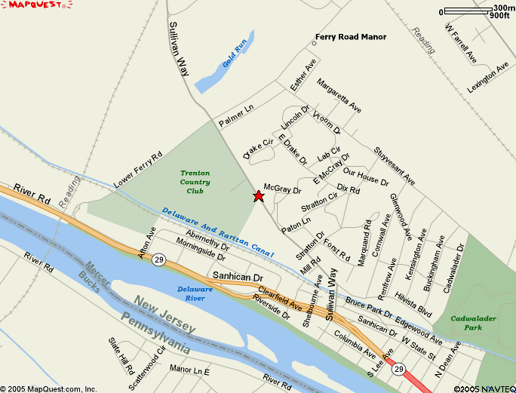

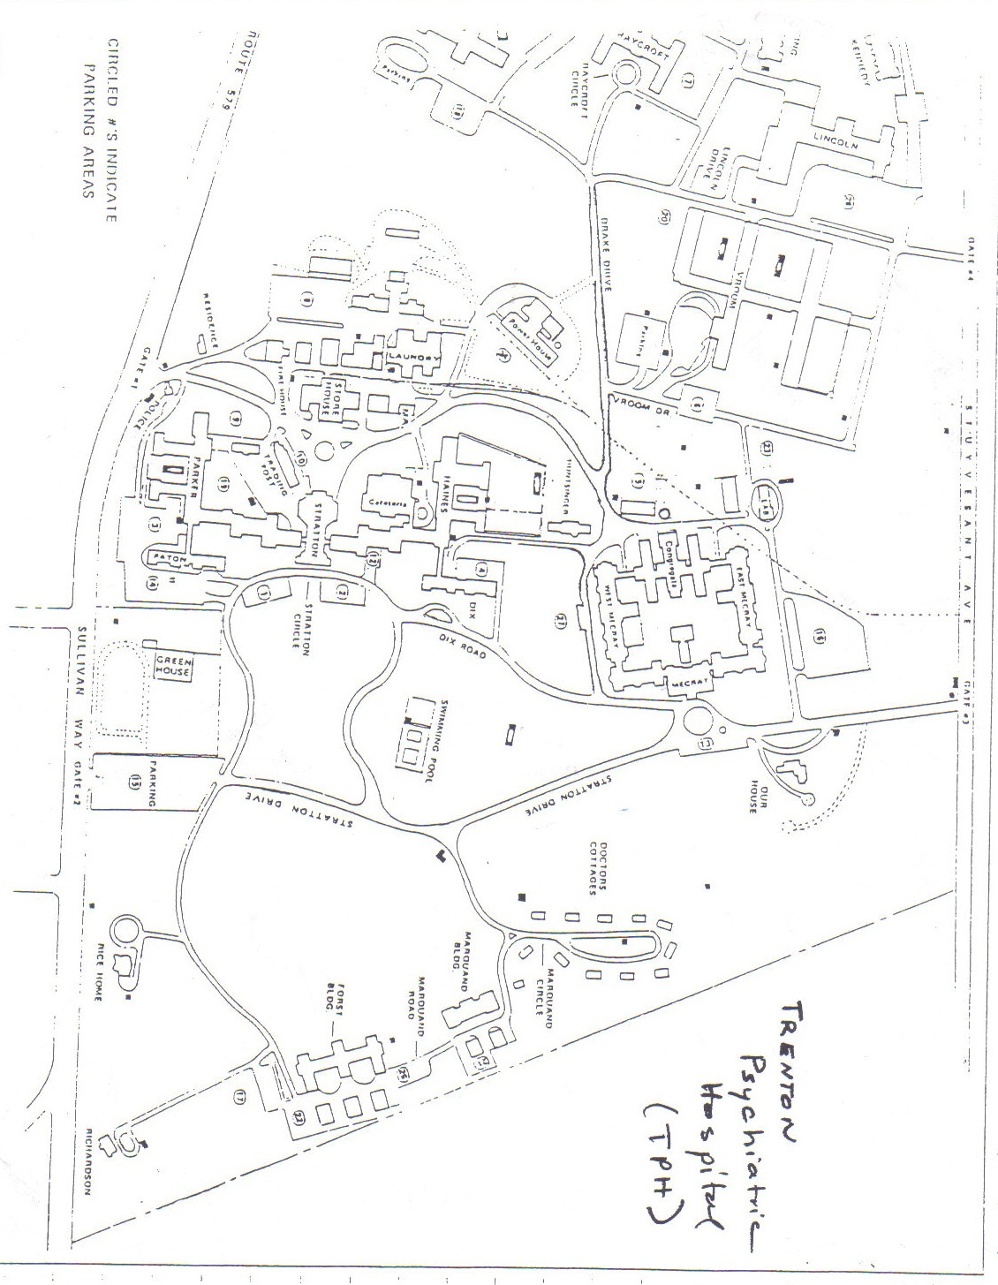
Carrier Clinic - Belle Mead Directions

FROM PRINCETON: Take Route 206 North into Princeton. At Route 206 and Nassau St., bear left and continue on Route 206 North for 8 miles. Turn left onto Route 601 at railroad bridge and follow signs 1 mile to Carrier (on the right).

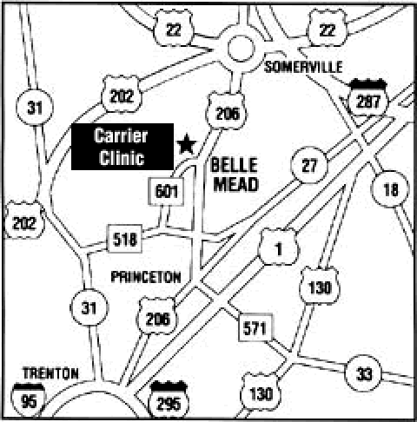

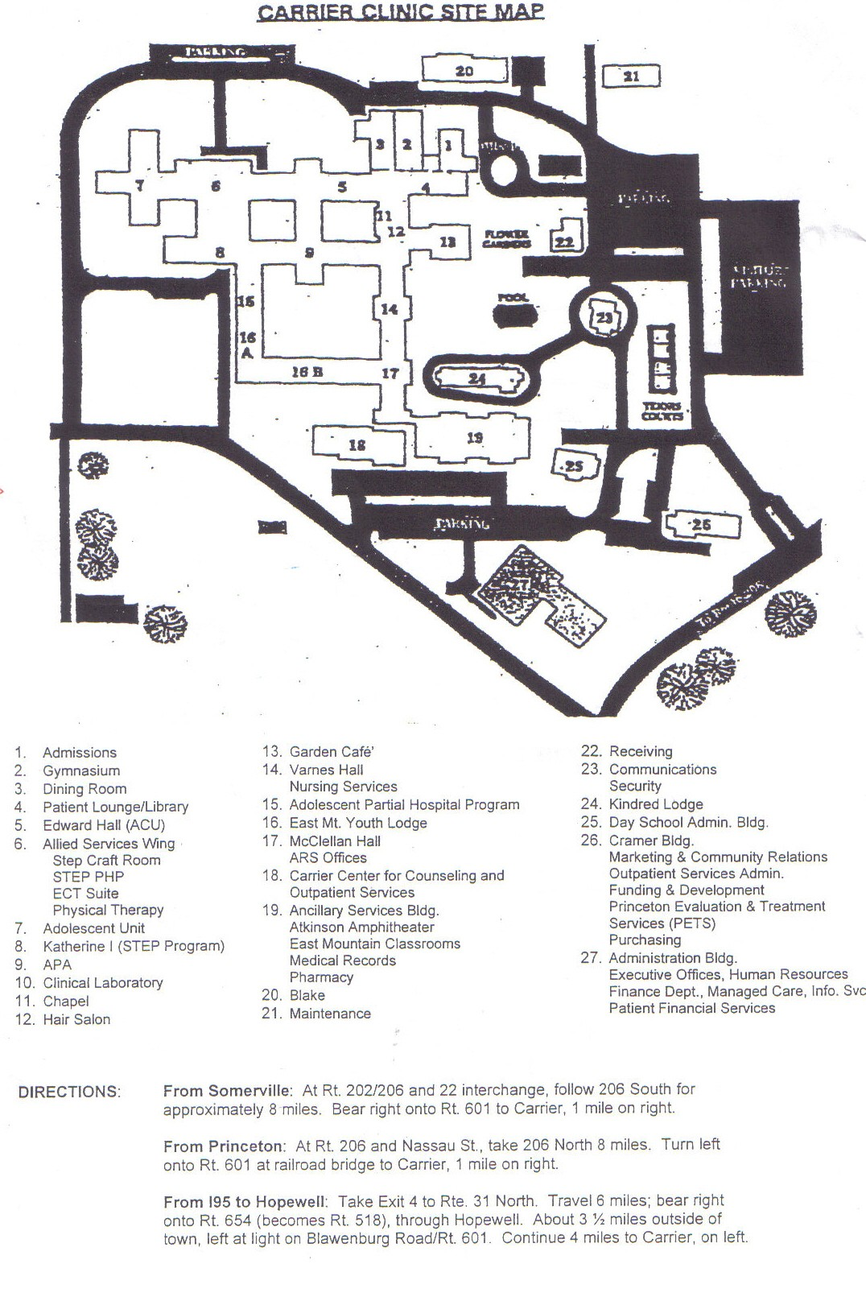
St. Francis Medical Center Directions

FROM 295 NORTH: Take 295 North to Exit 60 for Route 129 North to Trenton. Turn right at Hamilton Ave. (3rd traffic light). Follow Hamilton Ave. to the intersection of Hamilton Ave. and Chambers St. Hospital will be on your right. Turn right onto Chambers St. and entrance to parking garage will be on your left.

FROM ROUTE 1 SOUTH: Take Route 1 South to Route 129 Trenton exit. Go through first light and make right at Chambersburg exit. At light at the end of the ramp, make a right onto S. Broad St. Next light make a right onto Hamilton Ave. and follow directions above.

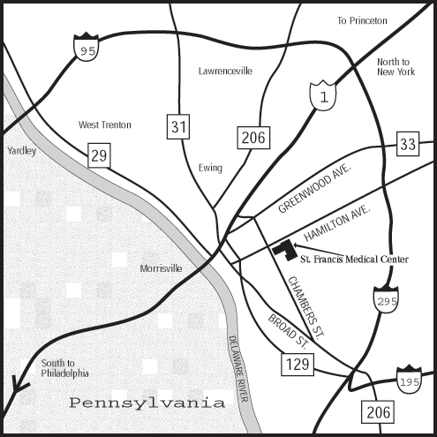
Capital Health Systems Fuld Campus Directions

Take Route 1 North to the Olden Ave. exit (left exit). At traffic light make a left onto Olden Ave. At next traffic light, make a left onto Brunswick Ave. Follow Brunswick Ave. for 2 blocks. Hospital will be on your left. Parking is located across from and behind the Medical Center.

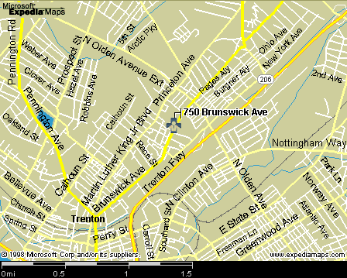
Capital Health Systems Mercer Campus Directions

FROM HAMILTON: Take 195 West to Route 29/Capital Complex/Lambertville. Go through the tunnel. Pass two lights and take the Calhoun St. exit. Stay to your left. Make a left at the light onto W. State St. At the next light make a right onto Prospect St. At second light make a left onto Bellvue Ave. Hospital will be on your right.

FROM PRINCETON: Take Route 1 South to Route 1 Business South/Trenton. Pass several lights and follow to Brunswick Circle. Enter the circle and take the second exit onto Princeton Ave. Follow Princeton Ave. south to the third traffic light. Make a right onto Olden Ave. Go to the third traffic light and make a left onto Prospect St. At fourth traffic light make a right onto Bellvue Ave. Hospital will be on your right.

Parking is available in the lot across from the main entrance.

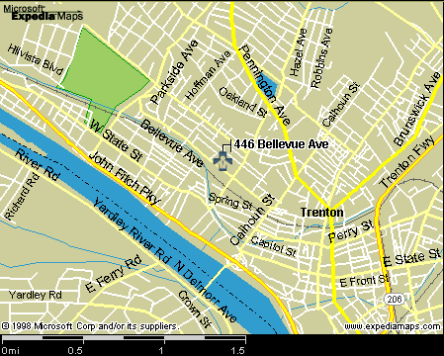

Virtua Memorial Hospital of Burlington County Directions

FROM TRENTON AREA: Take 295 South to exit 40 (Route 38 east Mt. Holly). Proceed 6 miles to Route 69 (Madison Ave.) Take the jug handle across Route 38 and follow the hospital signs. Hospital is two blocks off Route 38 on the right hand side.

Student parking is located off Madison Ave. on Ridge Ave. (across from the hospital).

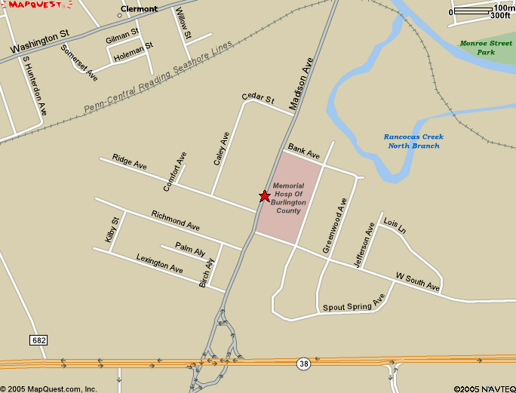

Princeton House Directions

Take Route 206 North into Princeton. Once in Princeton, Route 206 North bears to your left. Continue on Route 206 North to Herrontown Rd. (Hillside Rd. will be on your left directly before this). The parking lot for Princeton House is on your left.

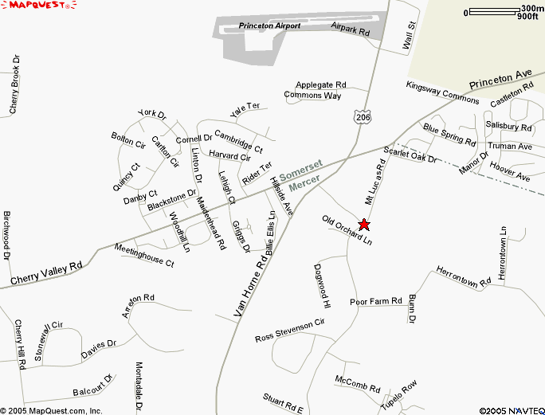

Medical Center at Princeton Directions

Take Route 206 North into Princeton. Once in Princeton, Route 206 will bear off to your left. You must stay straight onto Nassau St. Follow Nassau St. to Witherspoon St. and make a left onto Witherspoon St. The Medical Center is approximately ½ mile on your right.

Off-Site Parking at All Saint’s Church - Please seek further directions to this site from your instructor: The shuttle that will transport you to the hospital begins running at 6:00 a.m. It takes the shuttle about 5 minutes to make a trip from the parking lot to the hospital and back. The shuttle will drop you off in the front of the 281 building (Surgi Center). At the end of the day the shuttle will pick you up in the same place it dropped you off. The shuttle stops running at 6:00 p.m.

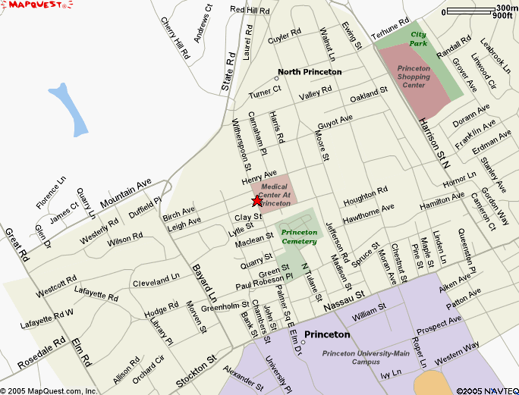
Virtua Voorhees Pediatrics Directions

Take the New Jersey Turnpike to Exit 4. Take Route 73 South, proceed past Marlton Circle (where Route 73 intersects Route 70) to Evesham Rd. Turn right on Evesham Rd. and proceed past four traffic lights (1 ½ miles). The 5th traffic signal is at Carnie Blvd. Turn left at the hospital entrance. The Hospital will be on your right.

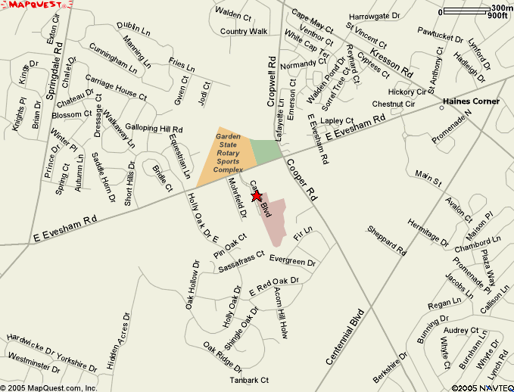

Deborah Heart and Lung Center Directions

From North Jersey–New York
Take the New Jersey Turnpike South to Exit 7 – Bordentown. Follow signs to Route 206 South. Stay in left lane and bear to the left, crossing Route 206 onto Route 68. Follow Route 68 through the entrance of Fort Dix. Turn right at the light onto an access road to Pemberton. Continue onto Fort Dix-Pemberton Road (Route 616). After passing schools turn left onto Catesville Road. At the stop sign turn left onto Pointville Road (Route 630). After passing Base housing turn right onto Juliustown Road (Route 669). At the light turn left onto Pemberton-Browns Mills Road. At the next light turn left onto Trenton Road. Deborah is approximately 1/4 mile on the right.

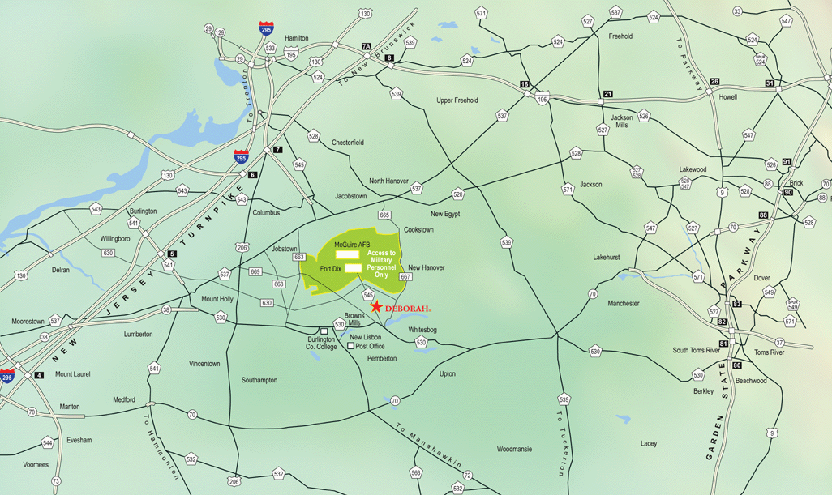
Robert Wood Johnson at Hamilton Directions

From I-295 Traveling North:
Take Exit 61 A, Arena Drive. Bear right off the exit. At second light make a left onto Whitehorse-Mercerville Road. At next light, bear right onto Whitehorse-Hamilton Square Road. At third light the hospital is to your right.
From I-295 Traveling South:
Take Exit 63. Make left at first light onto Klockner Road. At 3rd light make a right onto Whitehorse-Hamilton Square Road. Hospital is 100 yards on left.

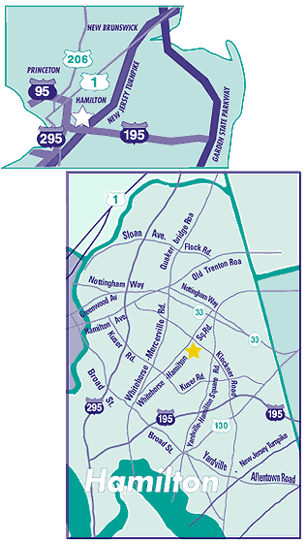

MERCER COUNTY COMMUNITY COLLEGE

DIVISION OF SCIENCE & HEALTH PROFESSIONS

Nursing Program

I have received a general information packet and the contents were reviewed.

I am enrolled in NUR______.

NAME___________________________________________________
PLEASE PRINT

SIGNATURE _____________________________________________

DATE__________________________

